**CSS**

**(CASCADING STYLE SHEET)**

**TABLE OF CONTENTS**

1. What is css ?

2. Basic Terminologies of CSS syntax

3. Ways in adding css to HTML

4. Working with selectors

5. Working with Colors, Border, links

6. Working with Box Model

7. Inline element or Block element

**1. WHAT IS CSS**

CSS (Cascading Style Sheet) is used for adding style/beauty/layouts to web pages.

CSS also known as Style Sheet is a list of CSS rules/rule sets that is use to style of html documents e.g

div{ color:red; } */* this is a single rule set*/*

p{font-weight:bold; margin:20px}  */* this is also a single rule set*/*

The above rule sets are 2 css rule set and we can have more rules set as possible.

CSS is a part of the frontend web development use for adding layouts and aesthetics to web pages.

**2. BASIC TERMINOLOGIES OF CSS SYNTAX**

**Selectors**

These are what we want to tag to be styled on a web page. for instance if you want to style a div tag or any other tag this is how you select them;

div {

  }

or i want to style a li tag;

li {

  }

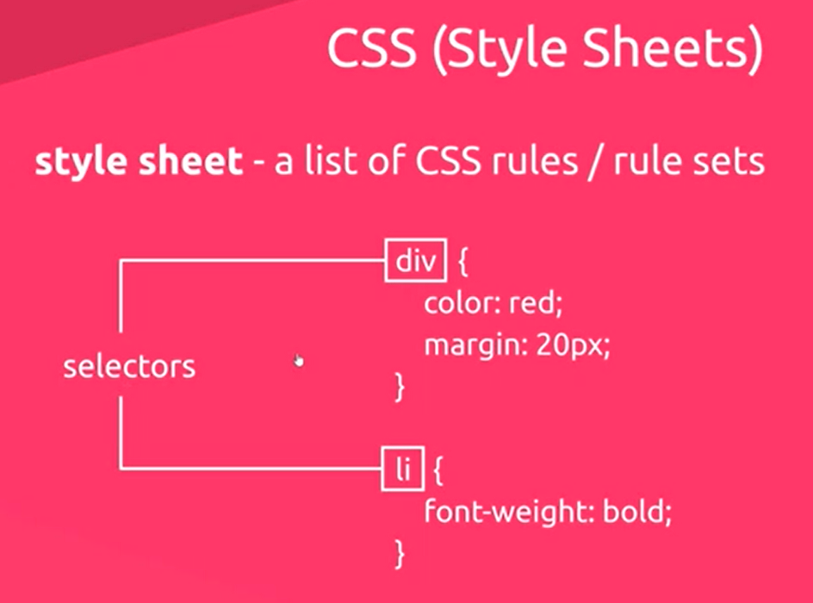

**Declarations**

These are list of key and value pair or properties and value pairs.

They are always in a parenthesis i.e { }

{

color : red;

margin: 20px;

}

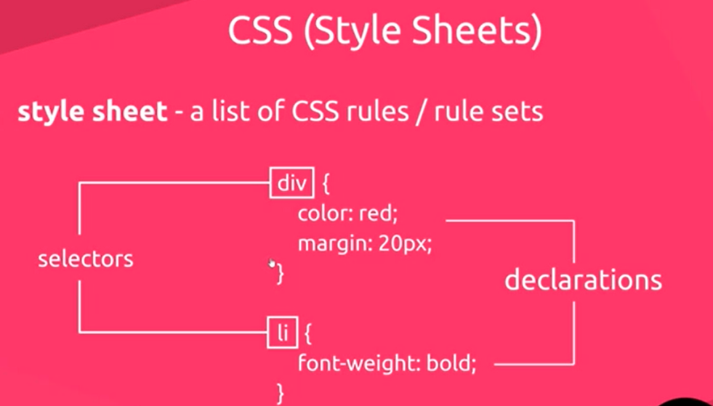The ***color*** *and* ***margin*** are the key or properties why the ***red*** *and* ***20px*** are the value. However we can have as many declarations as we want

**Comments**

*/* comment here, i wont display on the browser*/*

**3. WAYS IN ADDING CSS TO HTML**

There are three (3) different ways in adding Css to our Html

**Inline Styling**

Un-recommended and unprofessional, but good for quick testing.

**<p *style*="color:red">This is an inline styling, i am red in color </p>**

*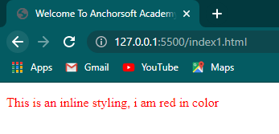Result in browser*

**Internal Styling**

Un-recommended and unprofessional, but good for quick testing. Using the <style> below the head section.

</head>

<style>

  p{

    color: blue

  }

</style>

<body>

  <p> This is an Internal styling, i am blue in color </p>

</body>

*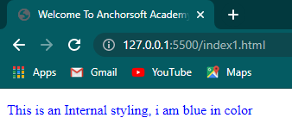Result in browser*

**External Styling**

This is the recommended one, has its own separate file and must be linked together with the html file using the <link> tag inside the head tag

<head>

  <title>Welcome To Anchorsoft Academy</title>

  <link *rel*="stylesheet" *href*="style.css">

</head>

HTML

<body>

  <p> This is an External styling, i am seagreen in color </p>

</body>

CSS

p{

  color:seagreen;

}

*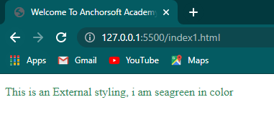Result in the browser*

*rel:* This means the relationship between the html file and the css file, which is a style sheet file that we are linking with the html

*href:* This is pointing at the location of the css file we created.

Note: if the css file is in a folder, you call the folder name then the file name, take for instance our style sheet is saved as style.css and in a folder called css, we will reference it like this:

<link *rel*="stylesheet" *href*="css/style.css">

***QUESTION***

* What is CSS and what does it stands for?

* Difference between selectors and decelerators?

* How do you comment on CSS?

* What are the major ways we can style our HTML and which is more preferred?

**4. WORKING WITH SELECTORS**

**Contextual/Descendant Selectors**

1. Adding class or ID

2. Adding parent tag

**Class**

This is adding a dot(.) to the class name on the html tag

*E.g*

*Html Page*

<p *class*="foodie"> Style Me, i have a class name foodie </p>

*CSS Page*

.foodie{

  color: red;

}

*Result in the browser*

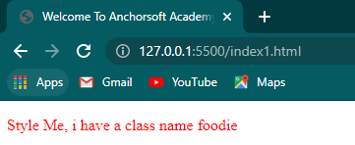

**ID**

This is adding an hash (#) to the id name on the html tag

*E.g*

*Html Page*

<p *id*="jump">Style Me also, i want to have a color of blue my id is jump</p>

*CSS Page*

#jump{

  color: blue;

}

*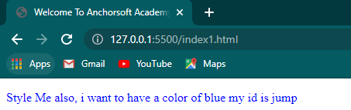Result In the Browser*

**Parent name /Tag name**

This is using the html tag itself instead of dot(.) and hash(#), which we have covered during the external styling section.

*E.g*

*Html Page*

<p>I'm a paragraph and my html tag is p, you can style me without class or id</p>

*CSS Page*

p{

  background-color: purple;

}

*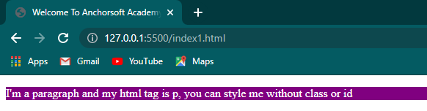Result in the Browser*

**Ways To Target Html Tags**

1. ID: uniquely targets a tag

2. Class: targets a group of tags

3. Tag name: h1,div ... tag-wide

4. Nested tag: For grouping #group1 .class3 {}

5. Comma separated for multiple styles:

***CLASS WORK***

* Build a web page having*

- Two pages Html and About having different contents

- The contents are to be styled using the three ways of css styling

**5. WORKING WITH COLORS, BORDER, LINKS**

**Colors**

* **Names :** gold, cyan, white, blue, purple, red etc
* **Hexadecimal(Hex)** : #ffffff (0-9,a-f)
* **RGB(Red, Green, Blue):** rgb(255,255,255) 0 - 255

**Border**

**border-width :** the thickness of the border

**border-style :** the style of the border (solid, double,dotted)

**border-color:** the color of the border

**Link Style : Anchor**

**a:hover** - kicks in when you mouse-over the link

**a:visited** - kicks in visited links

**a.active** - kicks in when clicked

**6. WORKING WITH BOX MODEL**

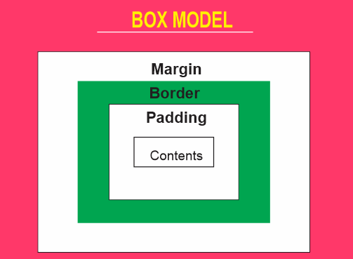Margin simply means spacing outside the box, why padding is spacing inside the box

**Margin**

This is the spacing outside the box and we have the;

Margin: 0px;

Margin-top: 10px

Margin-left: 20px

Margin-bottom: 10px

Margin-right: 20px

Margin: 10px 20px; /*top and bottom 10, left and right 20 */

This can also be written as; Margin: 10px 20px;

**Border**

This is the outline of the box and we have the;

border: 0px;

border-top: 10px solid red;

border-left: 20px dashed green;

border-bottom: 10px dotted blue;

border-right: 20px double black;

**Padding**

This is the spacing inside the box and we have the;

Padding: 0px;

Padding-top:10px

Padding-left: 20px;

Padding-bottom:10px;

Padding-right: 20px;

Padding: 10px 20px; /*top and bottom 10, left and right 20 */

**7. INLINE ELEMENT OR BLOCK ELEMENT**

In our last class on Html where we discussed on the types of elements and we mentioned Block level and Inline level elements, and we also made mention that it can be changed using css

We will be using our css to change a block level element to inline level element using the list item as example

*Html Page*

  <h3>Styling the block level list item to inline</h3>

<ul>

  <li> Home </li>

  <li> About </li>

  <li> Contact </li>

</ul>

*CSS Page*

ul{

  list-style-type: none;

}

ul li{

  display: inline-block;

}

*Result in the browser*

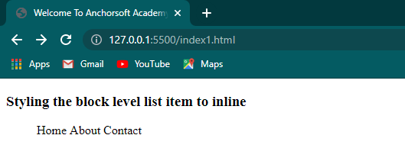

CLASS TO-DO

* Build a web page (using a template) having*

- Three pages Html, About and Contact us

- All pages should be link to one another and styled using one style sheet